**Streamlit with GitHub**

1. **On cmd:**

**pip install streamlit**

1. **Check if its installed or not**

**Cmd: streamlit hello**

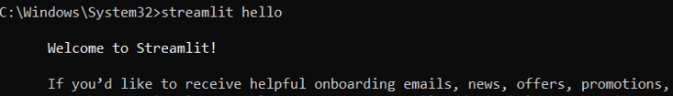

**This should be appeared:**

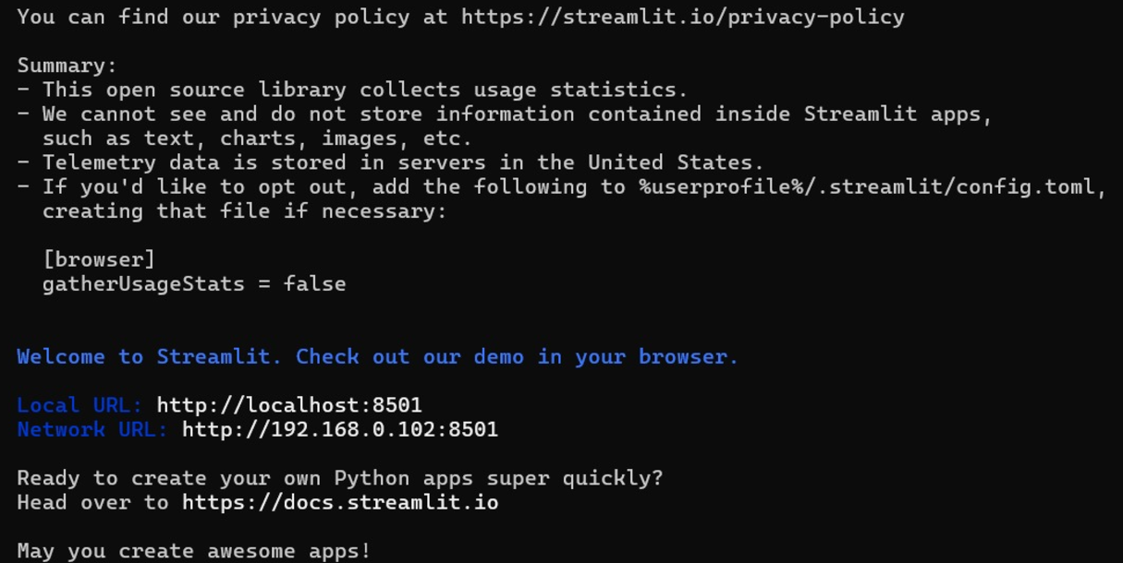

1. **Streamlit hello page**

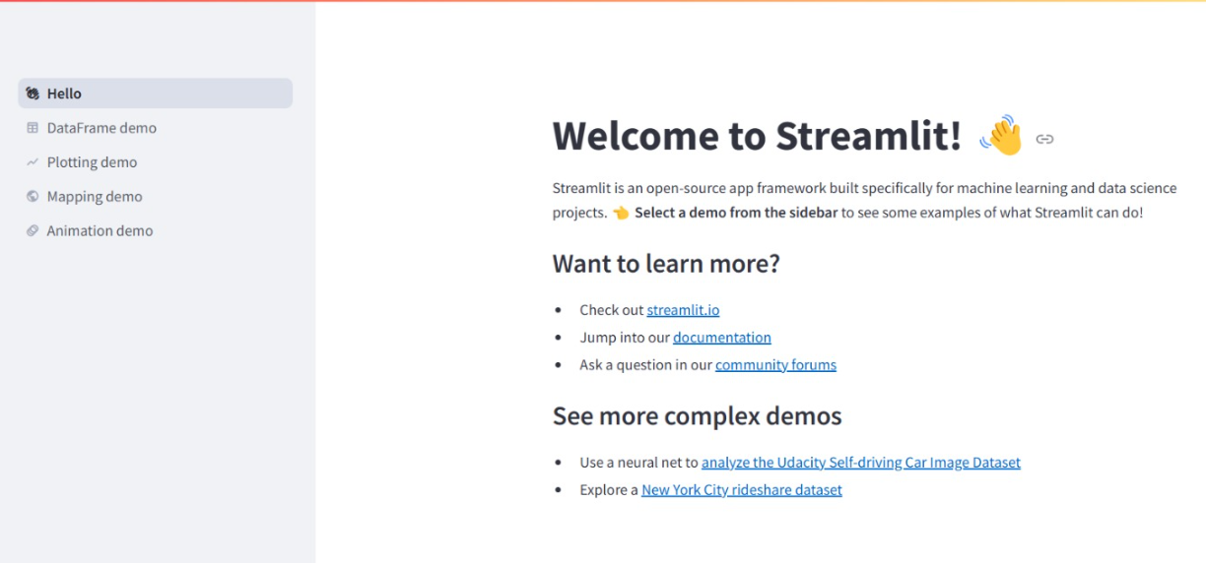

1. **Create a folder eg: devopsdemo go inside this folder in cmd**
2. **Then**

**Cmd to install venv(virtual environmnet) : python -m venv myenv**

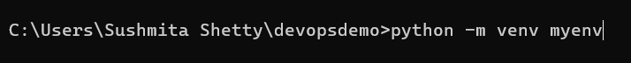

1. **Navigate to scripts in cmd : cd scripts**

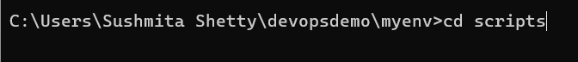

1. **Check the directory**

**Cmd: dir**

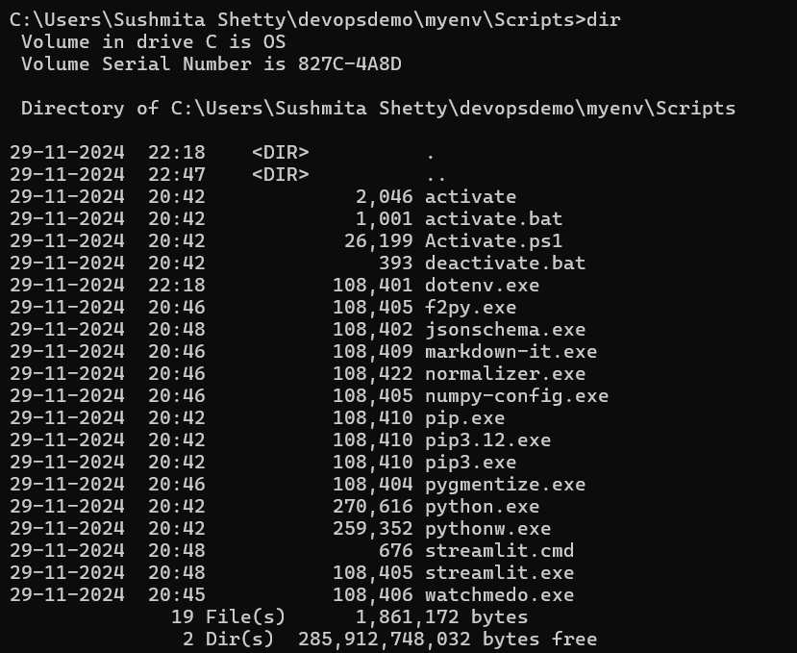

1. **Activate the streamlit environment:**

**Cmd: activate**

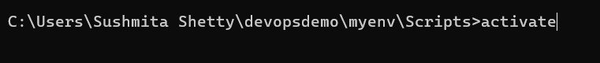

1. **Run activate**

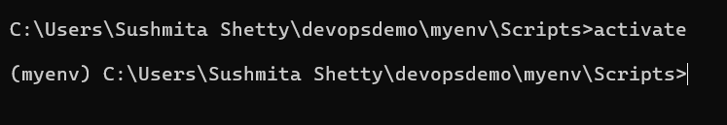

1. **Now get out of the scripts 🡪 cd ..**

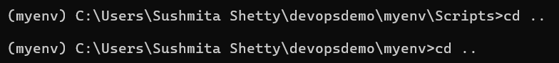

1. **And run the cmd: pip install streamlit**



1. **To verify run cmd : streamlit hello**

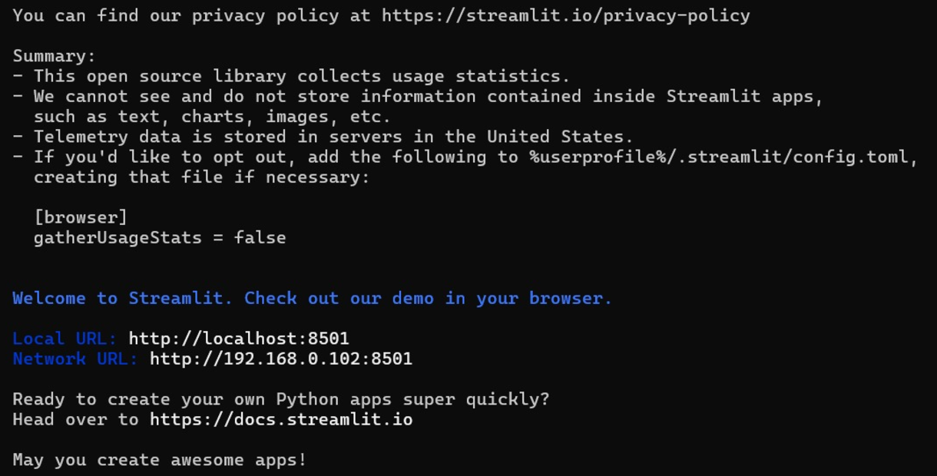

1. **Now go to vs code open the folder i.e demodevops which contains the myenv**

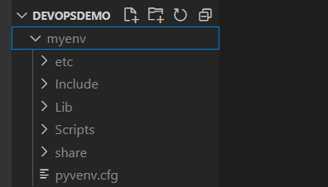

1. **Create a new file app.py in the folder**
2. **Go to the** [**https://docs.streamlit.io/**](https://docs.streamlit.io/)
3. **Go to** [**https://docs.streamlit.io/get-started/tutorials/create-an-app**](https://docs.streamlit.io/get-started/tutorials/create-an-app)
4. **Create a title page within app.js**

**Code:**

import streamlit as st

import pandas as pd

import numpy as np

st.title('Streamlit demo')

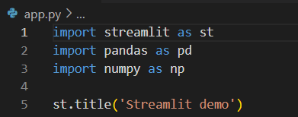

1. **Go to cmd :**

**streamlit run app.py**



1. **Output**

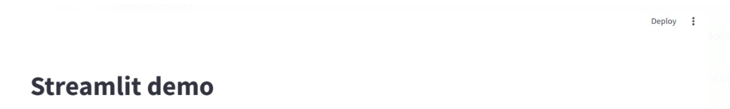

1. **Now you can refer multiple code snippet available in document to create a app eg:**

**Take input from user and display:**

**Code:**

import streamlit as st

import pandas as pd

import numpy as np

st.title('Streamlit demo')

name =st.text_input('Enter your name: ')

st.write("you entered:" , name)

**rerun in streamlit :**

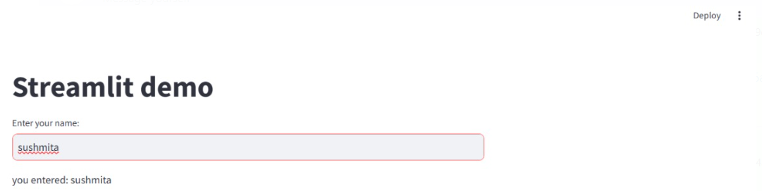

**Create df etc :**

import streamlit as st

import pandas as pd

import numpy as np

st.title('Streamlit demo')

st.write("Here's our first attempt at using data to create a table:")

st.write(pd.DataFrame({

    'first column': [1, 2, 3, 4],

    'second column': [10, 20, 30, 40]

}))

**rerun**

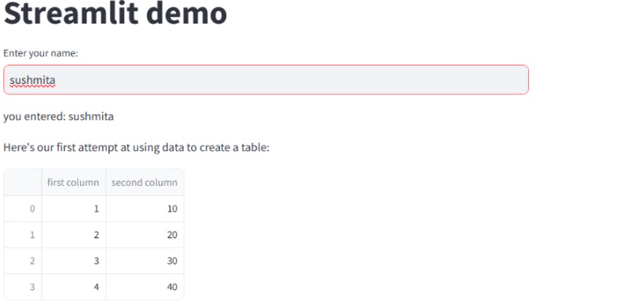

**Create a plot:**

**Code:**

import streamlit as st

import pandas as pd

import numpy as np

st.title('Streamlit demo')

chart_data = pd.DataFrame(

     np.random.randn(20, 3),

     columns=['a', 'b', 'c'])

st.line_chart(chart_data)

**rerun**

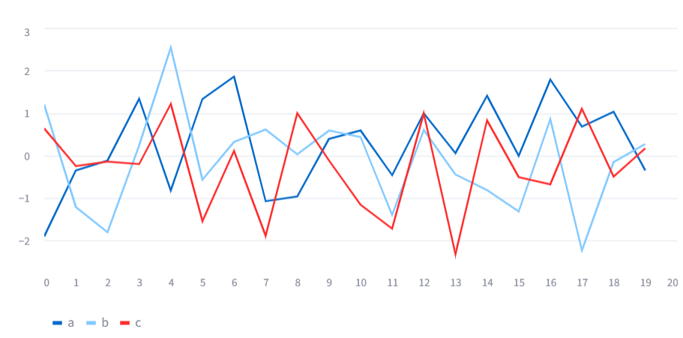

**Create a table**

**Code:**

import streamlit as st

import pandas as pd

import numpy as np

st.title('Streamlit demo')

dataframe = pd.DataFrame(

    np.random.randn(10, 20),

    columns=('col %d' % i for i in range(20)))

st.table(dataframe)

**rerun**

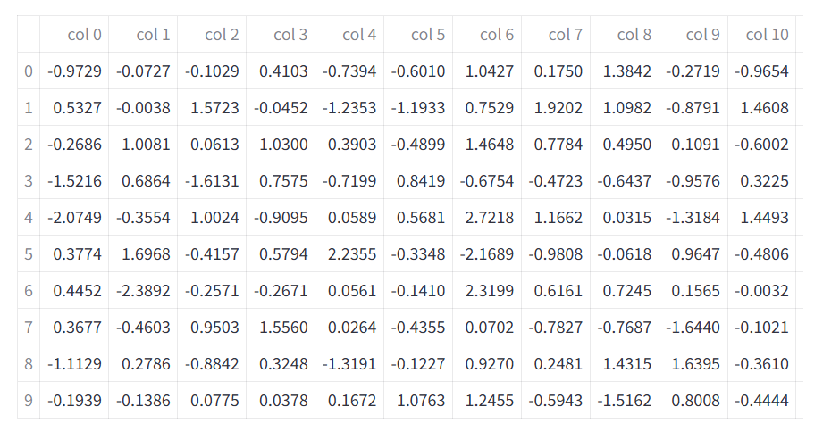

1. **Create a .env file in our environment outside myenv but within folder**
2. **On cmd run: pip install python-dotenv**

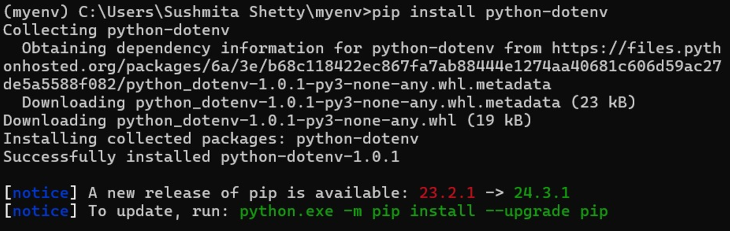

**Push your code to github**

1. **Create .gitignore file**

**(outside the myenv )**

**Content:**

#.gitignore

# Ignore the virtual environment folder

myenv/

env/

# Ignore Python cache files

_pycache_/

*.py[cod]

*.pyo

# Ignore system files

.DS_Store

Thumbs.db

# Ignore IDE/editor-specific files

.vscode/

.idea/

*.sublime-workspace

*.sublime-project

# Ignore logs and temporary files

*.log

*.tmp

# Ignore configuration files and secrets

.env

# Ignore Jupyter Notebook checkpoints (if applicable)

.ipynb_checkpoints/

# Ignore compiled Python files

*.pyc

1. **Initialize a repository in github**
2. **Initaialize a repo outside of myenv but within the folder cmd: git init**

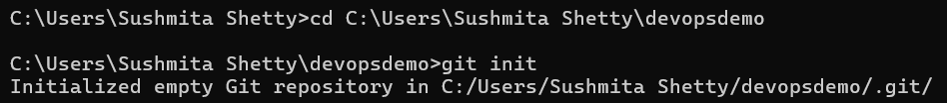

1. **Create a requirement.txt**

**Cmd:**



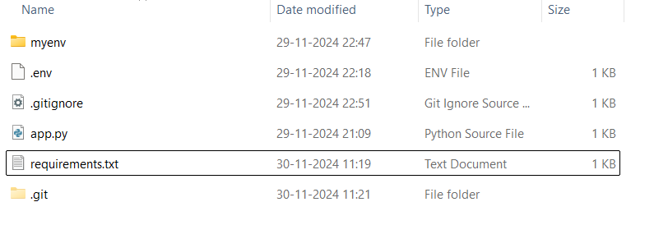

1. **Now cmd: git add .**



1. **Check the status: git commit**

**Write: Initial commit: Added .gitignore, app.py, and requirements.txt**

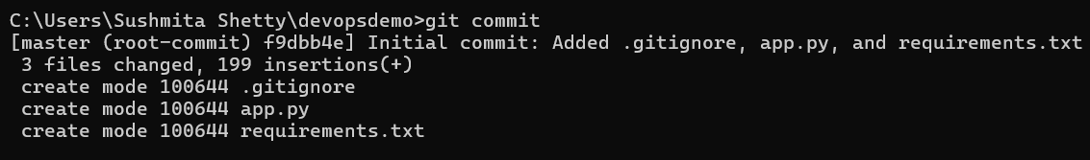

1. **Cmd: git status**

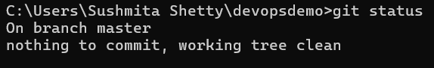

1. **Create a new githut repo**
2. **Copy the url**
3. **Connent to your repo : git remote add origin** [**https://github.com/sushmitashetty-19/streamlit-git.git**](https://github.com/sushmitashetty-19/streamlit-git.git)



1. **Verify: git remote -v**

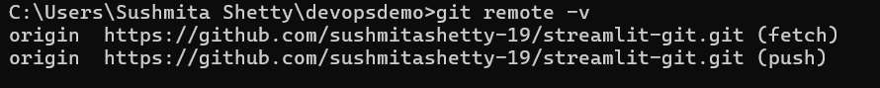

1. **Push your file : git push -u origin master**

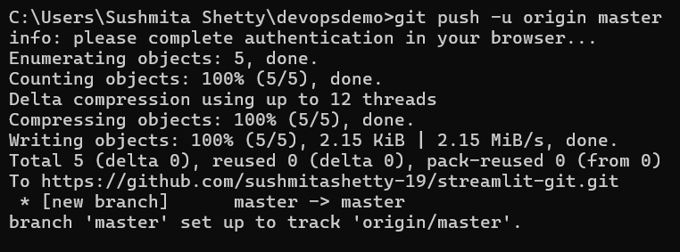

1. **While pushing or after pushing the error that you may encounter are:**

**First:**

During pushing, Git might throw a Permissions Denied Error

git push -u origin master



Run: git credential-manager clear

Go To Control Panel>User Accounts>User Accounts>Manage Credentials

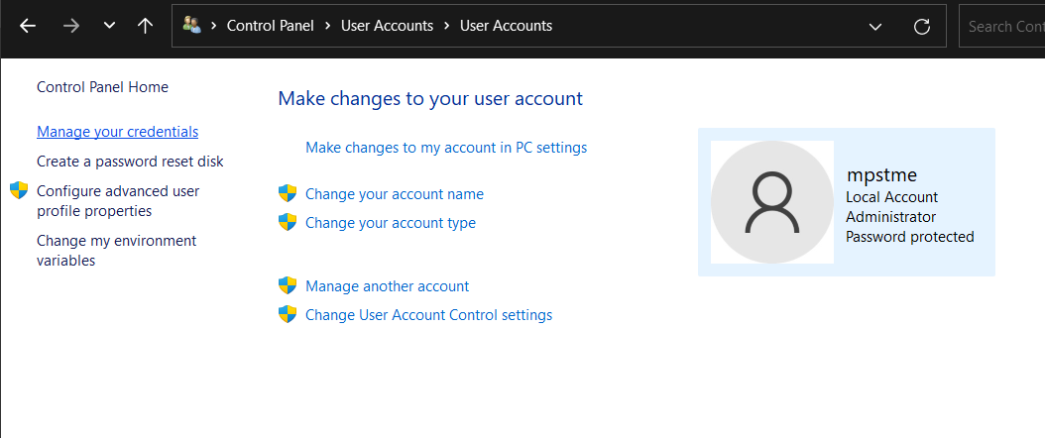

Remove your GitHub credentials

Push your files again: git push -u origin master

**Second:**

**After push you might get error in streamlit app for compatibility**

**To solve jush change the requirement.txt file:**

altair==5.5.0

attrs==24.2.0

blinker==1.9.0

cachetools==5.5.0

certifi==2024.8.30

charset-normalizer==3.4.0

click==8.1.7

colorama==0.4.6

gitdb==4.0.11

GitPython==3.1.43

idna==3.10

Jinja2==3.1.4

jsonschema==4.23.0

jsonschema-specifications==2024.10.1

markdown-it-py==3.0.0

MarkupSafe==3.0.2

mdurl==0.1.2

narwhals==1.14.3

numpy==2.1.3

packaging==24.2

pandas==2.2.3

pillow==11.0.0

protobuf==5.29.0

pyarrow==18.1.0

pydeck==0.9.1

Pygments==2.18.0

python-dateutil==2.9.0.post0

python-dotenv==1.0.1

pytz==2024.2

referencing==0.35.1

requests==2.32.3

rich==13.9.4

rpds-py==0.21.0

six==1.16.0

smmap==5.0.1

streamlit==1.40.2

tenacity==9.0.0

toml==0.10.2

tornado==6.4.2

typing_extensions==4.12.2

tzdata==2024.2

urllib3==2.2.3

watchdog==6.0.0

**save the new file and then on cmd check the status:**

**cmd: git status**

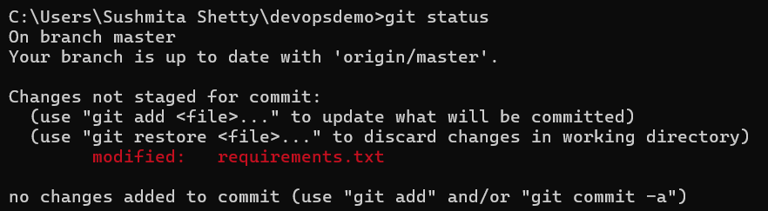

**Cmd: git add requiments.txt**



**Cmd: git commit -m "modified requirements.txt"**

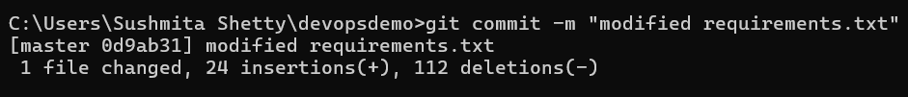

**Now just write cmd: git push**

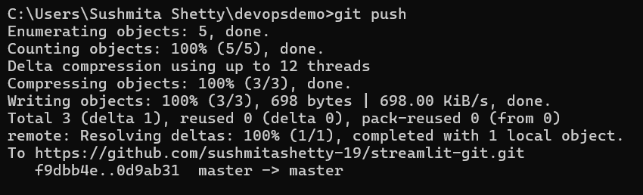

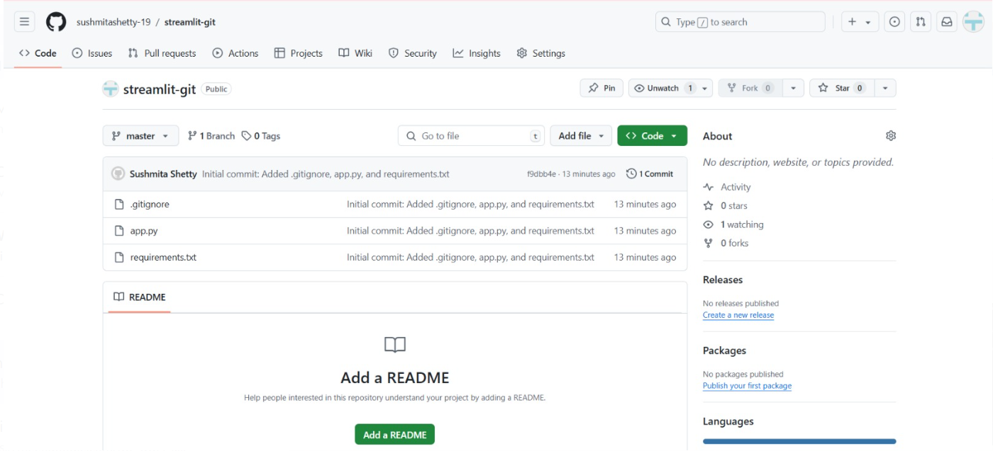

**Done successfully push the repo**

**Deploying app on the streamlit cloud**

1. **Go to Stramlit Community Cloud-> Login using GitHub**

1. **Deploy App**

**Deploy Your Streamlit App on Streamlit Cloud:**

